


REQUEST FOR PROPOSALS

RFP #05-25/26 Development Opportunity 2026



Response Deadline: Tuesday, February 3, 2026, at 2:00 PM ET

Deadline to Request Additional Information and Ask Questions: Thursday, January 15, 2026, at 5:00 PM ET

All questions will be posted and answered on the City’s website by Thursday, January 22, 2026, at 5:00 PM ET
PREPARED BY: City of Sumter
CONTACT: BJ Reed
breed@sumtersc.gov

- INTRODUCTION
The City of Sumter seeks proposals for the development of multiple City-owned properties for the purpose of redevelopment. The City currently has suitable parcels of land and will sell them at a discounted price to qualified developers that agree to redevelop the property for residential use, as well as commercial where permitted, and complete other necessary improvements to the property.
Following a review of proposals submitted by interested developers, the City will contact those parties it determines are best suited to enter into this venture with the City.

- REQUEST FOR PROPOSALS
The City of Sumter and its partner, the Santee-Lynches Regional Development Corporation were awarded a grant by the South Carolina State Housing Authority under its Neighborhood Initiative Program (NIP). The award facilitated the purchase and demolition of many blighted structures in the City’s most at-risk neighborhoods.
The Goal of the Neighborhood Initiative Program (NIP) is to stabilize property values through the removal of blighted properties in strategically targeted areas and replace with affordable housing where feasible.
The majority of these properties were acquired through the NIP Program, however some may have been acquired by different means and may be better suited for commercial development.
- Submittals
The City will accept submittals through Tuesday, February 3, 2026, at 2:00 PM ET. Submittals will be reviewed and evaluated based upon the criteria identified below:
- Developer Experience: Introduction and Description of Qualifications
  - Introduction to your proposal and to your organization.
  - Describe what makes you uniquely qualified to partner with the City in this redevelopment opportunity and why you would like to take on this project.
  - Describe the unique skills and experience of your project team, as well as what best qualifies your team to work on this project, including any relevant certifications and education.
- Development Plan: Project Description
  - Describe how you plan to develop the property with details such as housing type, unit size, and fit with neighborhood aesthetic. Sketches must be included but do not need to be professionally produced.
  - List information on the estimated purchase / lease price point of your unit(s) as well as whether the unit(s) will be offered for sale or rent. Home ownership is preferred.
- Financial Capacity: Real Estate Terms, Preliminary Budget, and Financing Plan
  - List proposed terms of real estate transaction including the proposed purchase price of the parcel(s) or $0.00 if seeking a donation and closing timeline.
  - Outline your preliminary budget for the project and how you plan to finance the work, including information on any grants or incentives you plan to utilize or apply for.
- Development Timeline
  - Summarize and outline your development timeline for the project.
- Statement
  - Statement of why the Firm/Company should be selected in this redevelopment project

III SUBMITTAL INFORMATION
  - Format of Submittal
Please complete the RFP #05-25/26 Development Opportunity 2026 Submission Form and upload the completed form along with supporting documentation, formatted to standard letter-size paper in pdf format. If you are submitting a proposal for more than one property, please complete a separate RFP #05-25/26 Development Opportunity 2026 Submission Form for each property, clearly identifying the supporting documentation for each address proposal. Additional promotional materials providing an overview of the firm or prior projects may also be submitted. All responses must be received by Tuesday, February 3, 2026, at 2:00 PM ET.

  - Scoring Criteria

Major Category | Criteria Summaries
Developer Experience  (POINT VALUE=25) | - The successful developer should have sufficient experience developing properties, all necessary qualifications and certifications, and a working knowledge of the Sumter community and its unique needs.
Development Plan  (POINT VALUE=25) | - The successful plan should include attractive and livable units that fit well with the surrounding neighborhood.
Financial Capacity  (POINT VALUE=25) | - The successful developer will have adequate financial resources to both purchase the property and develop it for occupancy.
Timeline  (POINT VALUE=20) | - The successful developer will be able to begin the project once awarded and finish it in an extremely timely manner.
Statement of why the Firm/Company should be selected  (POINT VALUE=5) | - Statement of why the FIRM/COMPANY should be selected in this redevelopment project.

  - Response Deadline:
All submittals must be uploaded to the City of Sumter’s website no later than 2:00 PM ET on Tuesday, February 3, 2026.
https://www.sumtersc.gov/departments/purchasing/rfp-rfq
  - Questions:
All questions regarding the submittal of this RFQ must be in writing and shall be directed to BJ Reed, Strategic Initiatives Manager via e-mail at: breed@sumtersc.gov.
Deadline to request additional information and ask questions: Thursday, January 15, 2026, at 5:00 PM ET.
All questions will be posted and answered on the City’s website by Thursday, January 22, 2026, at 5:00 PM ET.

- RIGHT TO REJECT
The City reserves the right to accept or reject any and/or all proposals, to cancel the Project as defined below, to waive irregularities and technicalities, and to request resubmission. The City shall be the sole judge of whether any proposal and/or the resulting Agreement is in its best interest, and its decision shall be final. The City reserves the right to accept or reject all or any part of a submission, if it is deemed in the best interest of the City. The City, in its sole discretion, may expand the scope of work to include additional requirements. The City reserves the right to investigate as it deems necessary to determine the ability of any proposer to perform the work or services requested. Each proposer, upon request, shall provide such information as the City deems necessary to make a determination.
- SUBMISSION DISCLAIMER
The City of Sumter may, at its sole discretion, request that proposers supplement their qualification with additional information following the initial submittal deadline.
- PROPOSED SCHEDULE
Deadline to request additional information and ask questions: Thursday, January 15, 2026, at 5:00 PM ET.
All questions will be posted and answered on the City’s website by Thursday, January 22, 2026, at 5:00 PM ET.

Submittals Due: Tuesday, February 3, 2026, at 2:00 PM ET.

ATTACHMENT A
PROPERTY INFORMATION:
Please be aware that the buyer is responsible for confirming the availability of water, sewer, electricity, and other needed utilities.

203 Woodlawn Ave (TMS# 229-14-03-001)
This parcel is located near the intersection of Woodlawn Dr. and Jackson St., zoned R-6 (Single Family Residential), and consists of 0.19 acres. Fair market value per Sumter County Tax Assessor’s Office is $1,550. Lot size is approximately 50 ft. x 150 ft. The proposed house plan should be based on comparisons to surrounding lots.

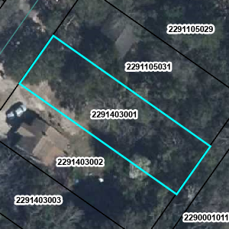

512 Dingle St (TMS# 227-03-05-010)
This parcel is located on Dingle St. between Purdy St. and Salem Ave., zoned R-6 (Single Family Residential), and consists of 0.18 acres. Fair market value per Sumter County Tax Assessor’s Office is $3,180. Lot size is approximately 50 ft. x 150 ft. The proposed house plan should be based on comparisons to surrounding lots.
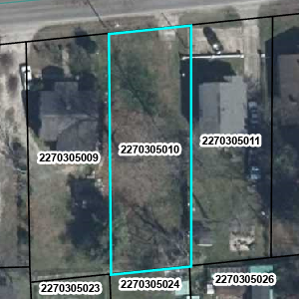

408 Dingle St (TMS# 227-03-05-034)
This parcel is located on Dingle St. between Salem Ave. and Wright St., zoned R-6 (Single Family Residential), and consists of 0.17 acres. Fair market value per Sumter County Tax Assessor’s Office is $3,000. Lot size is approximately 50 ft. x 150 ft. The proposed house plan should be based on comparisons to surrounding lots.

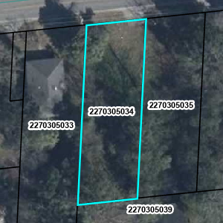

316 Wright St (TMS# 227-03-05-049)
This parcel is located on Wright St. between Dingle St. and Bradford St., zoned R-6 (Single Family Residential), and consists of 0.23 acres. Fair market value per Sumter County Tax Assessor’s Office is $3,000. Lot size is approximately 45 ft. x 215 ft. The proposed house plan should be based on comparisons to surrounding lots.

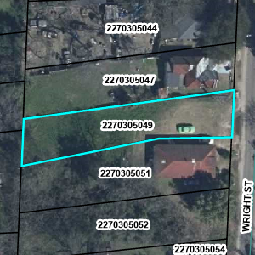

103 Gates St (TMS# 227-12-08-003)
This parcel is located on Gates St. between Atlantic St. and Hoyt St., zoned GR (General Residential), and consists of approximately 0.24 acres. Fair market value per Sumter County Tax Assessor’s Office is $4,000. Lot size is approximately 95 ft. x 112 ft. The proposed house plan should be based on comparisons to surrounding lots.

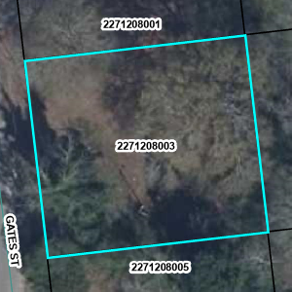

590 S Main St (TMS# 227-12-03-037)
This parcel is located on S Main St. between Atlantic St. and W Williams St., zoned GR (General Residential), and consists of approximately 0.13 acres. Fair market value per Sumter County Tax Assessor’s Office is $2,000. Lot size is approximately 50 ft. x 113 ft. The proposed house plan should be based on comparisons to surrounding lots.

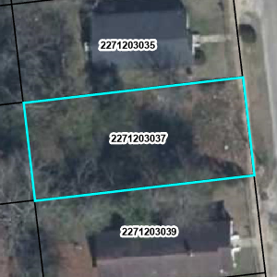
15 Branch St (TMS# 227-12-02-014)
This parcel is located on Branch St. between Atlantic St. and Foxworth St., zoned R6 (Single Family Residential), and consists of approximately 0.12 acres. Fair market value per Sumter County Tax Assessor’s Office is $3,030. Lot size is approximately 50 ft. x 110 ft. The proposed house plan should be based on comparisons to surrounding lots.

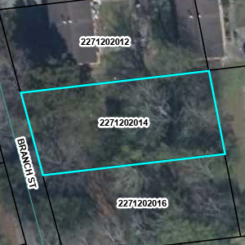

17 Foxworth St (TMS# 227-12-01-021)
This parcel is located at the corner of Foxworth St. and Maney St., zoned GR (General Residential), and consists of approximately 0.15 acres. Fair market value per Sumter County Tax Assessor’s Office is $2,600. Lot size is approximately 65 ft. x 90 ft. The proposed house plan should be based on comparisons to surrounding lots.

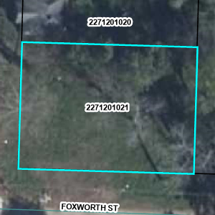

13 Foxworth St (TMS# 227-12-01-022)
This parcel is located near the corner of Foxworth St. and Maney St., zoned GR (General Residential), and consists of approximately 0.17 acres. Fair market value per Sumter County Tax Assessor’s Office is $2,000. Lot size is approximately 50 ft. x 150 ft. The proposed house plan should be based on comparisons to surrounding lots.

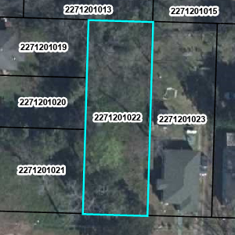

166 Hoyt St (TMS# 227-13-01-016)
This parcel is located between Maney St. and Warley St., zoned GR (General Residential), and consists of approximately 0.17 acres. Fair market value per Sumter County Tax Assessor’s Office is $3,000. Lot size is approximately 50 ft. x 150 ft. The proposed house plan should be based on comparisons to surrounding lots.

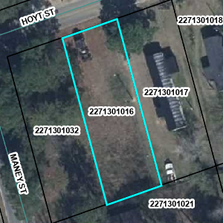

168 Hoyt St (TMS# 227-13-01-032)
This parcel is located at the corner of Hoyt St and Maney St., zoned GR (General Residential), and consists of approximately 0.17 acres. Fair market value per Sumter County Tax Assessor’s Office is $3,000. Lot size is approximately 50 ft. x 150 ft. The proposed house plan should be based on comparisons to surrounding lots.

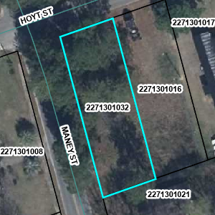

509 President St (TMS# 229-16-02-023)
This parcel is located near the intersection of President St and Peace Ave., zoned R6 (Single Family Residential), and consists of approximately 0.27 acres. Fair market value per Sumter County Tax Assessor’s Office is $2,320. Lot size is approximately 50 ft. x 225 ft. The proposed house plan should be based on comparisons to surrounding lots.

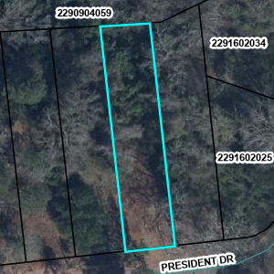

252 S Guignard Dr (TMS# 227-02-02-022)
This parcel is located on S Guignard between W. Oakland Ave and W. Bartlette St., zoned R-6 (Single Family Residential), and consists of approximately 0.13 acres. Fair market value per Sumter County Tax Assessor’s Office is $2,500. Lot size is approximately 50 ft. x 110 ft. The proposed house plan should be based on comparisons to surrounding lots.

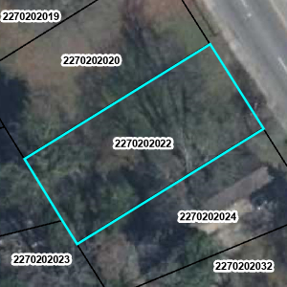

306 Brown St (TMS# 229-13-01-045)
This parcel is located on Brown St. near the intersection of Brown St. and Pine St., zoned R-6 (Single Family Residential), and consists of approximately 0.14 acres. Fair market value per Sumter County Tax Assessor’s Office is $2,000. Lot size is approximately 64 ft. x 90 ft. The proposed house plan should be based on comparisons to surrounding lots.

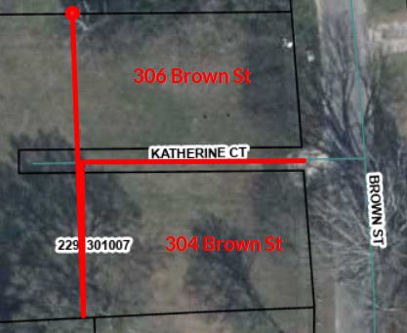

304 Brown St (TMS# 229-13-01-046)
This parcel is located on Brown St. near the intersection of Brown St. and Pine St., zoned R-6 (Single Family Residential), and consists of approximately 0.15 acres. Fair market value per Sumter County Tax Assessor’s Office is $2,000. Lot size is approximately 64 ft. x 90 ft. The proposed house plan should be based on comparisons to surrounding lots.

36 Gable Ct (TMS# 227-05-01-085)
This parcel is located on Gable Court, zoned R-6 (Single Family Residential), and consists of approximately 0.11 acres. Fair market value per Sumter County Tax Assessor’s Office is $2,400. Lot size is approximately 40 ft. x 122 ft. The proposed house plan should be based on comparisons to surrounding lots.

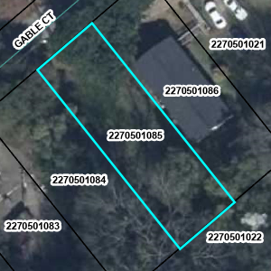

37 Gable Ct (TMS# 227-05-01-020)
This parcel is located on Gable Court, zoned R-6 (Single Family Residential), and consists of approximately 1.33 acres. Fair market value per Sumter County Tax Assessor’s Office is $13,000. The proposed house plan should be based on comparisons to surrounding lots.

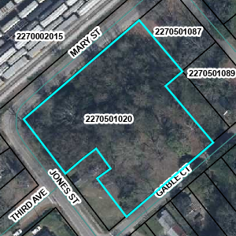

19 Third Avenue (TMS# 227-05-03-056)
This parcel is located on Third Avenue, zoned R-6 (Single Family Residential), and consists of approximately 0.15 acres. Fair market value per Sumter County Tax Assessor’s Office is $2,400. Lot size is approximately 60 ft. x 117 ft. The proposed house plan should be based on comparisons to surrounding lots.

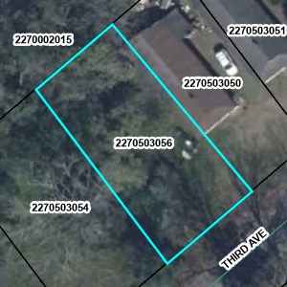

40 & 42 S Purdy Street (TMS# 228-14-02-048)
These parcels are located at the corner of S Purdy St and W Bartlette St, zoned R-6 (Single Family Residential), and together the parcels consist of approximately 0.12 acres. Fair market value per Sumter County Tax Assessor’s Office is $3,850. Lot size is approximately 68 ft. x 77 ft. The proposed house plan should be based on comparisons to surrounding lots.

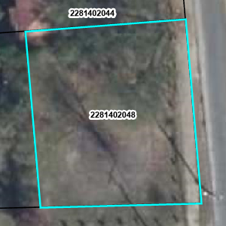

Please complete the RFP Submission Form for each property and upload the completed RFP Submission Form along with supporting documentation to the City of Sumter website no later than Tuesday, February 3, 2026, at 2:00 PM ET.

Double click on Icon below to open the RFP Submission Form:

