Sumter City-County Planning Commission

October 28, 2026

SV-25-03, 6320 Jasper Dr. (County)

- THE REQUEST

Applicant: | Marie Sanders
Status of the Applicant: | Authorized Agent
Request: | A request for approval of 2nd Cousin to 2nd Cousin relationship for a lifetime family conveyance to subdivide a +/- 1.0-acre lot from a larger +/- 2.79- acre tract.
Location: | 6310 Jasper Dr.
County Council District | District 1
Present Use/Zoning: | Residential / Agricultural Conservation (AC)
Tax Map Number: | 090-00-02-068
Adjacent Property Land Use and Zoning: | North – Residential / AC  South – Vacant / AC  East – Vacant / AC  West – Residential / AC

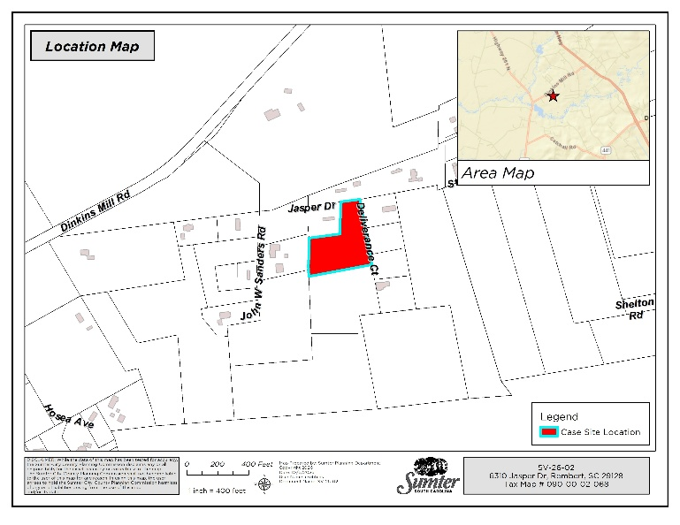
- BACKGROUND

The applicant is requesting subdivision variance approval for a 2nd cousin to 2nd cousin family relationship in order to subdivide a +/- 1.0-acre lot from a larger +/- 2.79-acre tract using the lifetime family conveyance exemption.

As shown on the map to the right, the parent tract is located on Jasper Dr. and Deliverance Ct. in Sumter County. Both of the accessways are private drives per GIS data. The property lacks sufficient public street frontage to divide the tract in a manner that meets public access requirements.

Because the proposed division does not have sufficient frontage on a public road, the property may only be subdivided via the lifetime family conveyance exemption outlined in Article 10 of the Sumter County— Zoning & Development Standards Ordinance. Lifetime conveyances allow an individual to transfer property to an immediate family member without having to meet standard subdivision requirements related to public road frontage.

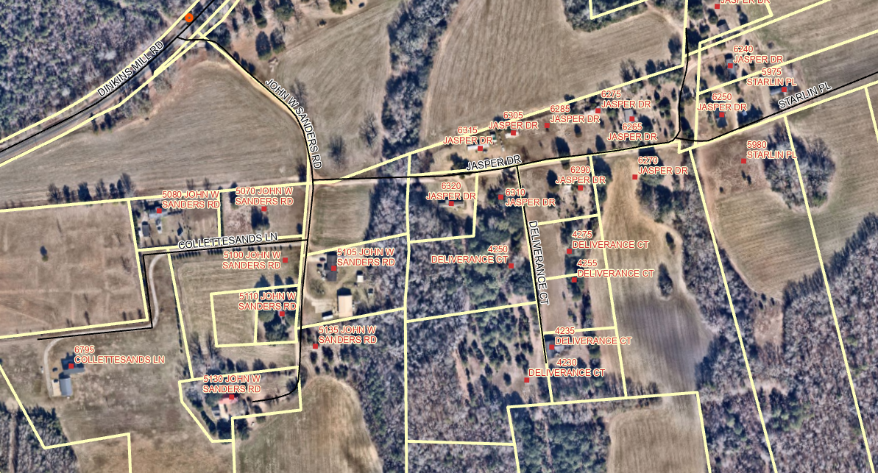
Easement on Jasper Dr.

Proposed Minimum 1.0 Acre

Above: Proposed Lot Layout Graphic

Article 10 of the Zoning Ordinance defines a lifetime conveyance as, “…conveyance of property from any first generation relative, including in-laws, as follows, parent to child and/or spouse of any such donee child, lifetime transfer from grandparent to grandchild and/or spouse of such donee child, from sibling to sibling and/or spouse of such donee sibling, lifetime transfer from aunt or uncle to niece or nephew and/or spouse of such donee niece or nephew, and lifetime transfer from cousin to cousin and/or spouse of such donee cousin…”

Any other family relationships requesting to use the lifetime conveyance provision must be reviewed and approved by the Planning Commission.

As a condition of any lifetime conveyance, the grantor must ensure that the grantee has sufficient access to the property either through direct access, through frontage on a road or through an access easement that has at least 15 ft. of width. The proposed plat references an easement on Jasper Dr. in front of the subject property, and it is presumed that either an actual or prescriptive easement that is at least 15 ft. wide exists along the entirety of Jasper Dr. The proposed plat also references an easement on Deliverance Ct. on the side of the property. The proposed plat, prepared by Lindler Surveying, Inc., dated November 7, 2024, is attached to this staff report as Exhibit 1.

V. STAFF RECOMMENDATION

Although 2nd cousins are not first-generation relatives as defined in the Sumter County— Zoning & Development Standards Ordinance, the intent of the lifetime conveyance exemption is to allow for flexibility in order to accommodate the establishment of residential family enclaves. In some families, a 2nd cousin relationship can be as significant as that between blood relatives.

Due to the lack of public road frontage, a lifetime family conveyance exemption is the only way additional lots can be created out of the parent parcel.

VI. PLANNING COMMISSION – October 28, 2026

